COVERING LONDON & THE HOME COUNTIES

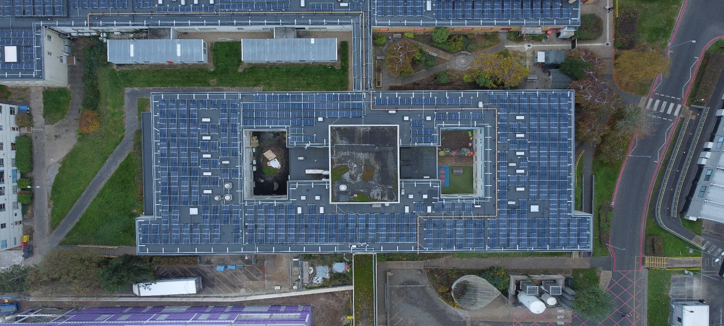

**Value: £5.3 million**

**Contract Dates:  Phased delivery (2021–2024)**

**Milton Keynes University Hospital (MKUH)**

**Solar and Roofing Infrastructure Upgrade**



**Key Challenges & Lessons Learned:**

**Live clinical environment:** Construction zones were often adjacent to or above critical care departments and staff corridors, requiring meticulous planning to maintain safe access and uninterrupted services. A carefully phased delivery strategy was developed in collaboration with hospital departments, including out-of-hours work and temporary M&E systems to ensure continuity. Dust, noise, and vibration were controlled using acoustic barriers and sealed enclosures, while segregated work zones with controlled access points safeguarded patients and staff.

**Stakeholder engagement:** Weekly meetings with hospital managers and clinical leads, monthly stakeholder reviews, and daily briefings for facilities and security staff ensured alignment and responsiveness. Real-time updates were shared via signage and noticeboards, and permit-to-work systems were coordinated with hospital engineers for high-risk areas.

**Programme Success:**

The project was completed on time and within budget, with no critical service disruptions. The installation of over 3,300 solar panels has already generated measurable energy savings, with nearly £50,000 saved on energy bills to date. The upgraded roofing and insulation systems have significantly improved indoor climate conditions, enhancing comfort for patients and staff.

**Description:**

The Milton Keynes University Hospital (MKUH) Solar and Roofing Infrastructure Upgrade was a £5.3 million project delivered over a 36-month phased programme from 2021 to 2024. Commissioned by the Milton Keynes University Hospital NHS Foundation Trust, the project aimed to enhance the hospital’s energy efficiency and reduce its long-term carbon footprint. All works were carried out while the hospital remained fully operational, serving over 500,000 patient interactions annually across inpatient, outpatient, emergency, and administrative services.

**Scope of Works:**

* Installation of a new 7500m² Langley flat roofing system
* Upgrading tapered insulation across multiple aging hospital wings
* Fitting over 3,300 photovoltaic solar panels
* Integrated mechanical and electrical (M&E) upgrades across live hospital buildings

***“Since the panels went live, we’ve saved nearly £50,000 on energy bills — a figure that will only grow as we complete the next phase. The new roofing has transformed previously outdated areas into more comfortable environments for patients and staff alike.”***